Visualisation Critique Assignment
Student Name | : (Ignore)
Student ID | : (Ignore)
Selected Dashboard | : Hospitalised Injury rates

1. Introduction (150 words)
Overview & Purpose | The Hospitalised injury rates page of the Australian Government's road crash dashboard shows how many people per 100,000 population were admitted to hospital after a road crash between 2011 and 2021 (Bureau of Infrastructure and Transport Research Economics [BITRE], n.d.). Its purpose is to let users compare risk fairly across groups of different sizes by year, remoteness, sex and age group. As part of BITRE's road safety statistics, it helps track progress towards the National Road Safety Strategy target of reducing serious injuries by at least 30% by 2030 (Infrastructure and Transport Ministers, 2021).
Intended Audience | The intended audience is policymakers, road safety agencies, researchers and interested members of the public.
Key User Questions | - How has the national hospitalised injury rate changed over time?  - Which age groups and sex face the highest injury risk?  - Are people living in remote areas at greater risk than those in major cities?

2. Data Processing and Governance (250 words)
Data Source & Processing | The dashboard uses custom hospital data from the Australian Institute of Health and Welfare's National Hospital Morbidity Database, with injury causes coded in ICD-10-AM, and population estimates supplied by the Australian Bureau of Statistics (BITRE, n.d.). Only patients admitted and discharged alive are counted. Rates per 100,000 population are then calculated by year, remoteness, sex and age group, excluding cases where these values are unknown (BITRE, n.d.).
Data Issues | The first issue is a broken time series. Victoria from July 2012 and New South Wales from June 2017 stopped counting patients treated only in emergency departments, so rates before and after these dates are not directly comparable (BITRE, n.d.). This is why the trend line has gaps between 2011–2012 and 2016–2017. The second is measurement bias. Hospital records alone are an imperfect measure of serious road injury, and linking them with police crash data produced estimates about 9% lower (Austroads, 2023). Remoteness is also based on the patient's usual residence, not the crash location (BITRE, n.d.). This means the remote rate describes where injured people live, not which roads are most dangerous.
How Issues Are Addressed | Both issues are only partly communicated. The trend chart's information icon warns users to use caution when comparing over time (BITRE, n.d.). However, the legend labels, such as "Change in admissions 2012", do not explain the cause, which appears only on the Glossary page. The remoteness icon clarifies residence, but nothing on the page tells users that hospital counts can overstate serious road injuries.

3. Visualisation Critique (500 words)
Visualisation 1 – Annual injury rate trend with series breaks
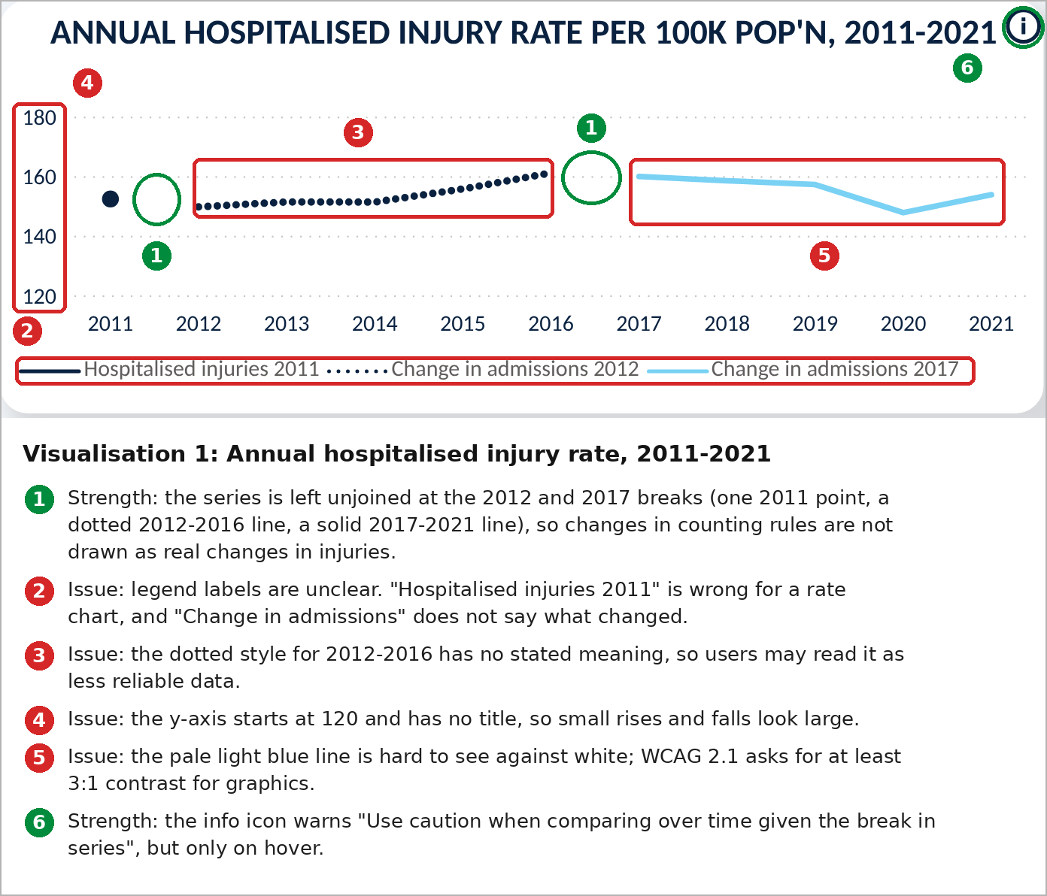 | Design Principal / issue:  Honest representation of a broken series; line style, labelling, scale and colour contrast.
Evidence / observation:
The rate is drawn as three unconnected series: one 2011 point, a dotted 2012–2016 line and a light blue 2017–2021 line (annotation 1). The legend calls the first series "Hospitalised injuries 2011" although the chart shows rates, and "Change in admissions" does not say what changed (2). The y-axis starts at 120 with no title (4), so the rise from 149.7 in 2012 to about 161 in 2016 fills most of the plot height. The light blue line is pale against the white background (5).
Evaluation
Leaving gaps is a strength: it follows government guidance not to join points across a break, even with a dotted line (Government Analysis Function, n.d.-b), so a change in counting rules is not shown as a real change in injuries. However, the same guidance advises caution with dotted or dashed lines, and here the dotted style has no stated meaning, so users may read 2012–2016 as less reliable instead of differently counted (3). WCAG 2.1 requires graphical objects to have at least 3:1 contrast with adjacent colours (World Wide Web Consortium [W3C], 2018), and the pale line makes the latest period the hardest to see. Labelling the first series "Hospitalised injuries" also invites confusion with the counts page, and a y-axis title stating "rate per 100,000" would remove ambiguity. Because the cause of the breaks appears only in a hover tooltip (6) and the Glossary, the chart is honest but not self-explanatory.

Visualisation 2 – Injury rate by remoteness area
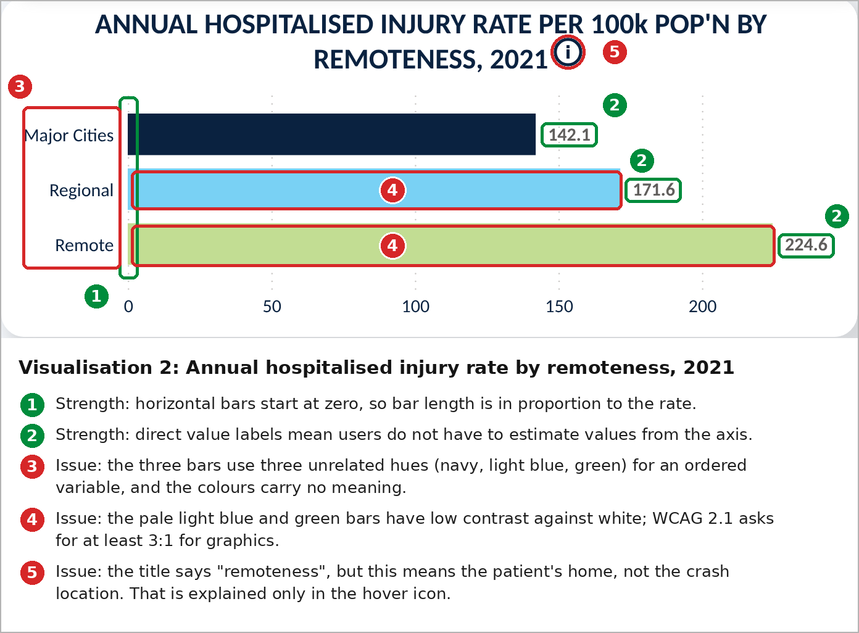 | Design Principal / issue:  Visual encoding (length and colour) and accessibility.
Evidence / observation:
Horizontal bars start at zero and are ordered from Major Cities to Remote, with direct value labels (1, 2). Each bar uses an unrelated hue: navy, light blue and green (3). The light blue and green bars are pale against the white background (4). The title says "remoteness", but only the info icon explains that this means the patient's usual residence (5). The national rate of 153.8 appears only in a separate card beside the chart.
Evaluation
Starting bars at zero follows guidance that bars should always begin at zero so differences are not exaggerated (Government Analysis Function, n.d.-a), so users correctly see that the Remote rate is 58% higher than Major Cities. Direct labels remove the need to estimate. However, remoteness is ordered, and government guidance recommends shades of one colour for data where order carries meaning (Government Analysis Function, n.d.-c); light-to-dark shades would reinforce that order. Titling the chart "by remoteness of residence" would stop users reading it as showing where crashes happen. The pale bars also risk falling short of the WCAG contrast minimum (W3C, 2018). A reference line at 153.8 would show at a glance which areas sit above the national rate.

4. Interaction and Usability (200 words)
Interactive feature | What does it do? | Evaluation
Feature 1: Filter (slicers) | Dropdowns for year, remoteness, sex and age group, with multi-select and a Reset button, filter the visuals on the page. | Effective. Users can answer targeted questions, such as rates for young males in remote areas, and Reset returns to the default view.
Feature 2: Click graph to filter (cross-filtering) | Clicking a bar filters or highlights the other visuals (Microsoft, n.d.). Selecting Remote changed the headline rate to 224.6 and overlaid remote age-group rates on the national bars. | Partly effective. The overlay supports comparison, but the only cue is a bold label: slicers still read "All" and the headline title is unchanged, so users may mistake 224.6 for the national rate.
Feature 3: Tooltips and information icons | Hovering a data point shows its rate and population, and information icons explain the series breaks and remoteness definition. | Partly effective. Population context aids interpretation, but key caveats appear only on hover, so users may miss them, and government guidance warns that hover text may not give screen reader users an equivalent experience (Government Analysis Function, n.d.-b).

5. Recommendations (200 words)
Recommendation | Issue addressed | Expected improvement
1. Replace the trend chart's legend labels and dotted style with one solid line style and a short on-chart note: "Series break: Victoria (2012) and NSW (2017) stopped counting emergency-only cases." | Unclear legend, unexplained dotted line and caveats hidden in hover and the Glossary. | Users understand the gaps without hovering, and the chart avoids dotted lines with no stated meaning (Government Analysis Function, n.d.-c).
2. Recolour the remoteness bars in light-to-dark shades of one colour with dark outlines, and retitle the chart "by remoteness of residence". | Unrelated hues for an ordered variable, pale low-contrast bars and the residence definition. | Colour reinforces the order from Major Cities to Remote, bars meet the 3:1 contrast minimum (Government Analysis Function, n.d.-d; W3C, 2018), and users do not read it as crash location.
3. Show active selections in visual titles, for example "Remote areas, 2021", and add a national-rate reference line to the remoteness chart. | Click-to-filter changes values while slicers still read "All". | Users always know which group they are viewing and how it compares with the national rate.

References
Austroads. (2023). A national approach to measuring non-fatal crash outcomes stage 2: An Australian approach (Publication No. AP-R694-23). https://austroads.gov.au/publications/road-safety/ap-r694-23
Bureau of Infrastructure and Transport Research Economics. (n.d.). Hospitalised injury [Dashboard]. Retrieved October 15, 2026, from https://www.bitre.gov.au/resource/road-safety/hospitalised-injury
Government Analysis Function. (n.d.-a). Bar charts (Introduction to data visualisation e-learning, Module 5). Retrieved October 15, 2026, from https://analysisfunction.civilservice.gov.uk/support/communicating-analysis/introduction-to-data-visualisation-e-learning/module-5-bar-charts/
Government Analysis Function. (n.d.-b). Line charts (Introduction to data visualisation e-learning, Module 8). Retrieved October 15, 2026, from https://analysisfunction.civilservice.gov.uk/support/communicating-analysis/introduction-to-data-visualisation-e-learning/module-8-line-charts/
Government Analysis Function. (n.d.-c). Using our colour palettes in Microsoft, R and Python. Retrieved October 15, 2026, from https://analysisfunction.civilservice.gov.uk/policy-store/codes-for-accessible-colours/
Government Analysis Function. (n.d.-d). Using our colour palettes in Microsoft, R and Python. Retrieved October 15, 2026, from https://analysisfunction.civilservice.gov.uk/policy-store/codes-for-accessible-colours/
Infrastructure and Transport Ministers. (2021). National road safety strategy 2021–30. Commonwealth of Australia. https://www.roadsafety.gov.au/sites/default/files/documents/National-Road-Safety-Strategy-2021-30.pdf
Microsoft. (n.d.). How visuals cross-filter each other in a Power BI report. Microsoft Learn. Retrieved October 15, 2026, from https://learn.microsoft.com/en-us/power-bi/explore-reports/end-user-interactions
World Wide Web Consortium. (2018). Web content accessibility guidelines (WCAG) 2.1. https://www.w3.org/TR/WCAG21/

